Books by Stephen Michael Shearer
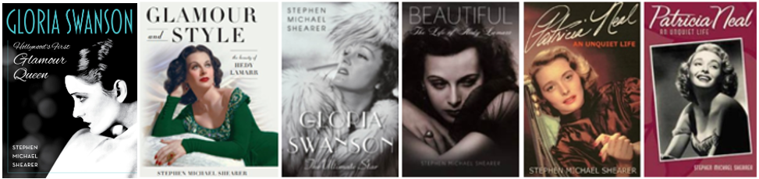

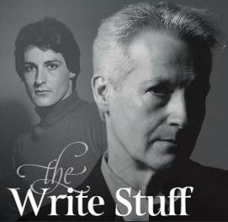

Featured Documentaries
Boulevard A Hollywood Story Bombshell: The Hedy Lamarr Story

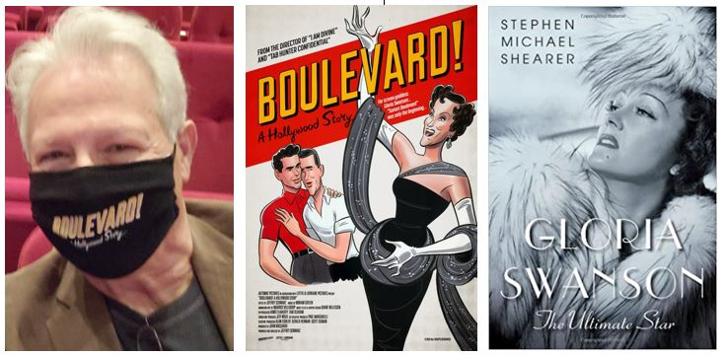

Theatrically Released Movie
To Olivia
(Based on Book by Stephen Michael Shearer – “Patricia Neal: An Unquiet Life)
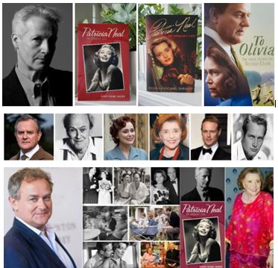

Dallas TV Series
(The Early Years)
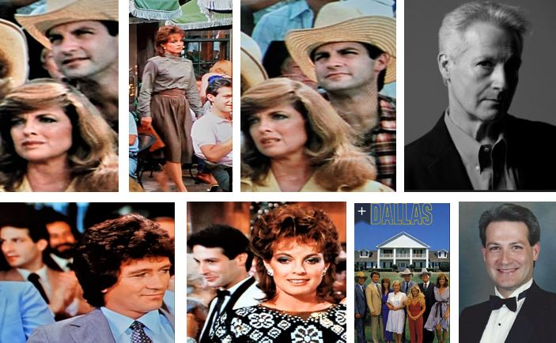

CONTACTS

Authors Literary Agent Representation:
Marsal Lyon Literary Agency LLC
Agent - Deborah Ritchken
PMB 121
665 San Rodolfo Dr. 124
Solana Beach, CA 92075
(858) 492-8009
Deborah@MarsalLyonLiteraryAgency.com

Publicist:
Michael at Mad Max Associates
(201) 962-5854
mpwmadmax@gmail.com

Authors Website:
www.smsmybooks.com

Publisher:
"Gloria Swanson: Hollywood’s First Glamour Queen"
(Release Date: November 2024)

"Glamour & Style: The Beauty of Hedy Lamarr"
Lyons Press. An imprint of Globe Pequot, the trade division of Rowman & Littlefield
64 S. Main St.
Essex, CT 06426

Publisher:
"Gloria Swanson: The Ultimate Star" & "Beautiful: The Life of Hedy Lamarr"
St. Martin's Press (Macmillan Publishers)
175 Fifth Avenue
New York, NY 10010
(646) 307-5546
John.karle@stmartins.com
speakers@macmillan.com

Publisher:
“Patricia Neal: An Unquiet Life”
University Press of Kentucky
Jackie Wilson
jackie.wilson@uky.edu
Adapted as a major motion picture starring Hugh Bonneville, Keeley Hawes, and Sam Heughan, TO OLIVIA is out now on Sky Cinema in the U.K.
U.S. Theater Release 2022 – Now available on DVD and multiple streaming platforms.

